DropBox

1. Enter in your Drop Box Develop account at <https://www.dropbox.com/developers/apps>.
2. Push the button: **Create App.**

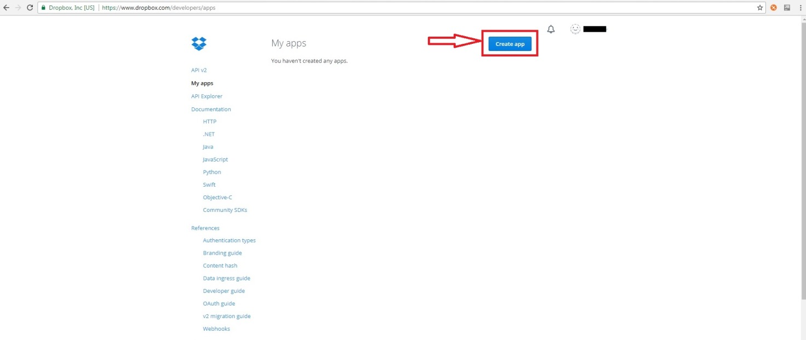

1. Choose an API: Dropbox API.
2. Choose the type of access you need and name of your app. Then clickon the button **Create app.**

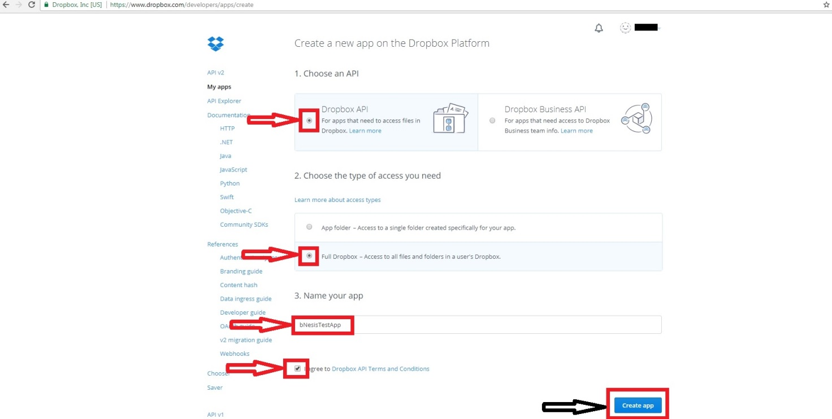

1. There is: App key and App secret. In **Redirect URI s**enter the URL that you will use as the Callback URL during authentication.

